**DB ASSIGNMENT 1**

**Umamah Hussain**

**21L-1858**

**Tables for Reference:**

1. **Patient**

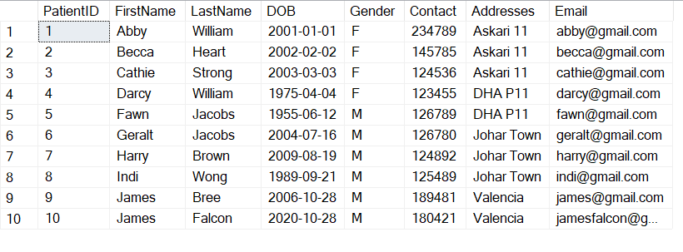

1. **Medical Staff**

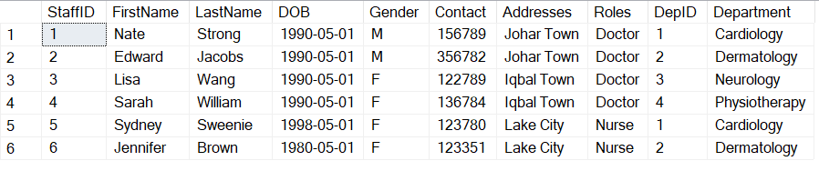

1. **Appointments**

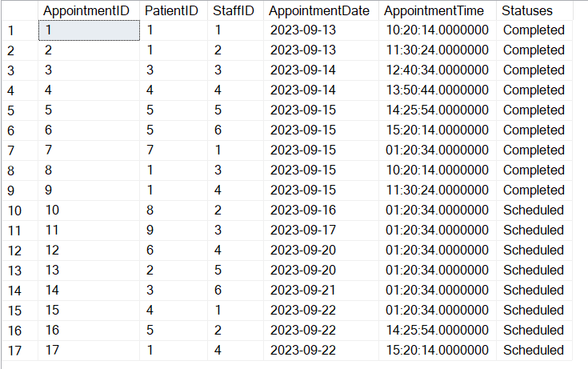

1. **Medical Records**

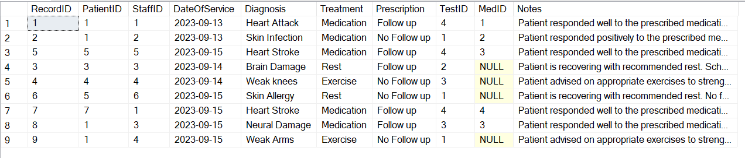

1. **Departments**

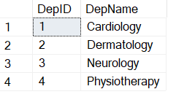

1. **Billing**

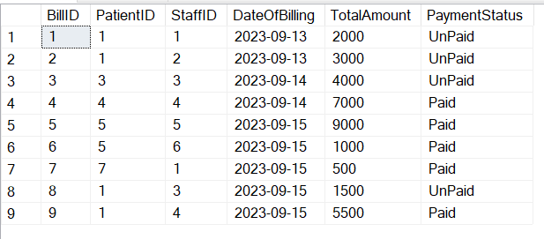

1. **Tests**

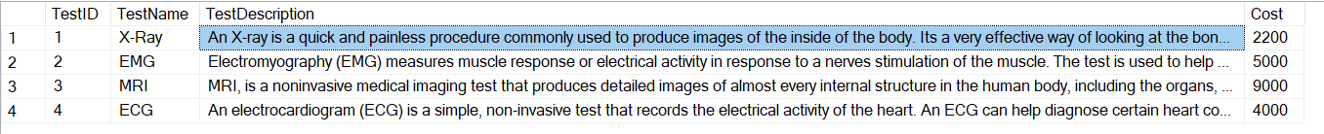

1. **Medication**

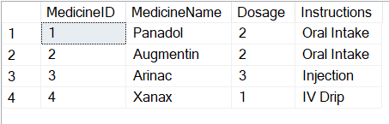

**Queries:**

**--1. List female patients whose contact number ends with 5 or 6 and were treated by “dr.sarah”**

select P.PatientID, concat (P.FirstName, ' ',P.LastName ) as PatientName, P.Contact, M.StaffID,concat (M.FirstName, ' ',M.LastName ) as StaffName

from Patient P

inner join Appointments A on A.PatientID=P.PatientID

inner join MedicalStaff M on M.StaffID=A.StaffID

where M.FirstName='Sarah' and P.Gender='F' and (P.Contact like '%5' or P.Contact like '%6')

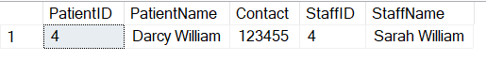

**--2. list all nurses younger than 30**

select M.StaffID, concat (M.FirstName, ' ',M.LastName ) as StaffName,M.Roles, M.DOB as age

from MedicalStaff M

where M.Roles='Nurse' and DATEDIFF(year,M.DOB,getdate())<30

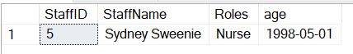

**--3. Retrieve appointments with a "Scheduled" status for male patients (ordered by appointment date)**

select P.PatientID, concat (P.FirstName, ' ',P.LastName ) as PatientName,P.Gender, A.Statuses ,A.AppointmentDate

from Patient P

inner join Appointments A on A.PatientID=P.PatientID

where A.Statuses='Scheduled' and P.Gender='M'

order by A.AppointmentDate asc

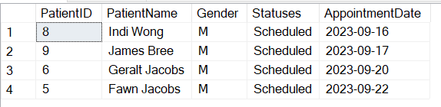

**--4. Retrieve the top 3 most expensive tests along with their descriptions**

select top(3) T.TestID, T.TestName,T.Cost,T.TestDescription

from Tests T

order by T.cost desc

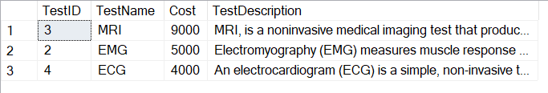

**--5. Find all appointments scheduled for the future**

select* from Appointments A

where A.Statuses='Scheduled'

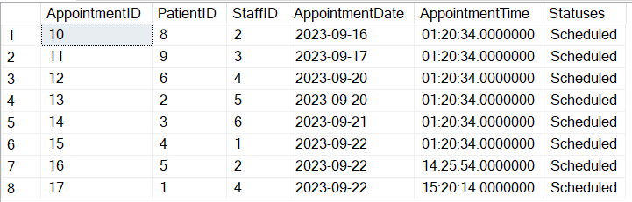

**--6. List patients who have the same last name as any medical staff (ordered by last name)**

select concat (P.FirstName, ' ',P.LastName ) as PatientName, concat (M.FirstName, ' ',M.LastName ) as StaffName

from Patient P

inner join MedicalStaff M on M.LastName=P.LastName

order by P.LastName asc, M.LastName asc

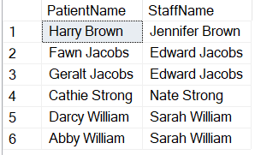

**--7/9. Identify Patients Who Haven't Received a Bill**

select A.PatientID

from Appointments A

except

select B.PatientID

from Billing B

**or**

select distinct P.PatientID ,concat (P.FirstName, ' ',P.LastName ) as PatientName

from Appointments A

inner join Patient P on P.PatientID=A.PatientID

left join Billing B on A.PatientID=B.PatientID where B.PatientID is null

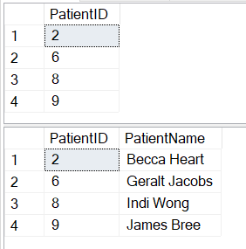

**--8. List All Medications and Their Usage Instructions:**

select* from Medications

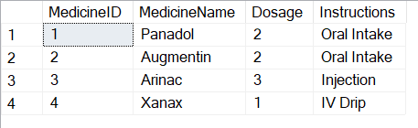

**--10. Find Patients Who Have Appointments But No Medical Records**

select P.PatientID,concat (P.FirstName, ' ',P.LastName ) as PatientName

from Patient P

inner join Appointments A on A.PatientID=P.PatientID

left join MedicalRecords M on M.PatientID=A.PatientID where M.PatientID is null

order by P.PatientID asc

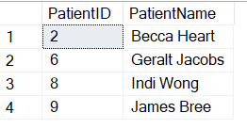

**--11. Find Patients Who Have Appointments, Medical Records, or Bills**

select distinct P.PatientID, concat (P.FirstName, ' ',P.LastName ) as PatientName

from Patient P

right join Appointments A on A.PatientID=P.PatientID

left join MedicalRecords M on M.PatientID=P.PatientID

left join Billing B on B.PatientID=P.PatientID

----------------------------------------------

select distinct P.PatientID, concat (P.FirstName, ' ',P.LastName ) as PatientName

from Appointments A, Patient P, Billing B, MedicalRecords M

where P.PatientID=A.PatientID OR P.PatientID=B.PatientID OR P.PatientID=M.PatientID

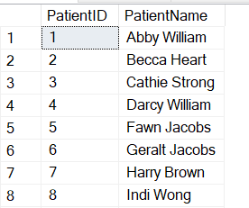

**--12. Find all patients who have had appointments with doctors in the 'Cardiology' department.**

select P.PatientID, concat (P.FirstName, ' ',P.LastName ) as PatientName, concat (M.FirstName, ' ',M.LastName ) as StaffName, M.Department

from Patient P

inner join Appointments A on A.PatientID=P.PatientID

inner join MedicalStaff M on M.StaffID=A.StaffID

where M.Department='Cardiology' and M.Roles='Doctor'

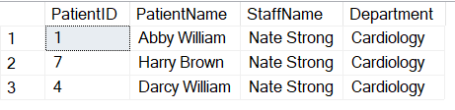

**--13. Find the doctors (medical staff) who have treated patients born after 1990 and have 'Paid' billing status.**

select P.PatientID, concat (P.FirstName, ' ',P.LastName ) as PatientName, P.DOB ,concat (M.FirstName, ' ',M.LastName ) as StaffName, B.PaymentStatus

from Patient P

inner join Appointments A on P.PatientID=A.PatientID

inner join Billing B on A.PatientID=B.BillID

inner join MedicalStaff M on M.StaffID=A.StaffID

where B.PaymentStatus='Paid' and P.DOB>'1990-12-12'

order by P.PatientID asc

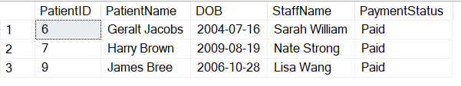

**--14. List all patients who have either 'Scheduled' or 'Completed' appointments.**

select distinct P.PatientID, concat (P.FirstName, ' ',P.LastName ) as PatientName, A.StaffID,concat (M.FirstName, ' ',M.LastName ) as StaffName ,A.Statuses

from Patient P

inner join Appointments A on A.PatientID=P.PatientID

inner join MedicalStaff M on M.StaffID=A.StaffID

where A.Statuses='Scheduled' or A.Statuses='Completed'

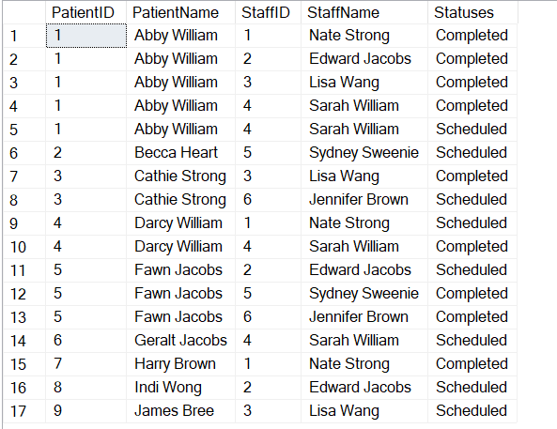

select distinct P.PatientID, concat (P.FirstName, ' ',P.LastName ) as PatientName

from Patient P

inner join Appointments A on A.PatientID=P.PatientID

where A.Statuses='Scheduled' or A.Statuses='Completed'

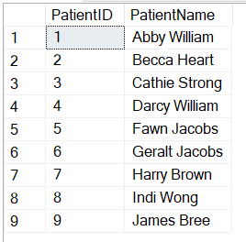

**--15. Find all patients who have both a medical record and a billing record.**

select distinct P.PatientID, concat (P.FirstName, ' ',P.LastName ) as PatientName

from Patient P

right join MedicalRecords M on M.PatientID=P.PatientID

right join Billing B on B.PatientID=P.PatientID

**or**

select distinct P.PatientID, concat (P.FirstName, ' ',P.LastName ) as PatientName

from Patient P, MedicalRecords M, Billing B

where P.PatientID=M.PatientID and P.PatientID=B.PatientID

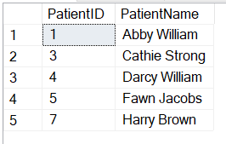

**--16. Get a list of patients who have undergone the 'X-ray' test or have been treated by 'Dr. Lisa Wang'**

select P.PatientID, concat (P.FirstName, ' ',P.LastName ) as PatientName, concat (MS.FirstName, ' ',MS.LastName ) as StaffName,T.TestName

from Patient P

inner join MedicalRecords M on M.PatientID=P.PatientID

inner join MedicalStaff MS on M.StaffID=MS.StaffID

inner join Tests T on M.TestID=T.TestID

where MS.FirstName='Lisa' and MS.LastName='Wang' or T.TestName='X-ray'

order by PatientID asc

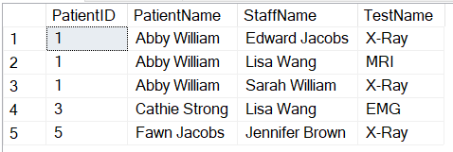

**--17. Find all patients who have had appointments with doctors in every department**

select P.PatientID, concat (P.FirstName, ' ',P.LastName ) as PatientName

from Patient P

where

(

select count(distinct M.DepID)

from MedicalStaff M

inner join Appointments A on A.StaffID=M.StaffID

where

A.PatientID=P.PatientID

)=(select count(D.DepID) from Departments D)

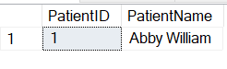

**--18. Find patients who have received at least two different medications,**

**--along with the list of medications they have received.**

select P.PatientID, concat (P.FirstName, ' ',P.LastName ) as PatientName, count(M.MedID) as Meds

from Patient P

inner join MedicalRecords M on M.PatientID=P.PatientID

group by P.PatientID,concat (P.FirstName, ' ',P.LastName )

having count(distinct M.MedID)>=2

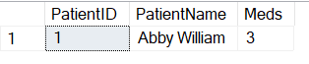

**--19. List the names of patients who have scheduled appointments along with the department they are associated with**

select P.PatientID, concat (P.FirstName, ' ',P.LastName ) as PatientName,concat (M.FirstName, ' ',M.LastName ) as StaffName,M.Department

from Patient P

inner join Appointments A on P.PatientID=A.PatientID

inner join MedicalStaff M on M.StaffID=A.StaffID

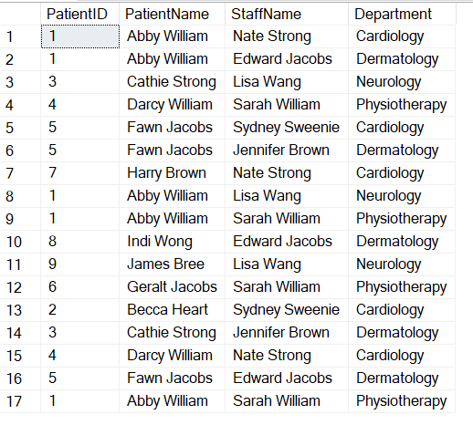

**--20. Retrieve the names of patients along with their medical records, including diagnosis and**

**--treatment, and the names of the doctors who treated them**

select P.PatientID, concat (P.FirstName, ' ',P.LastName ) as PatientName, concat (M.FirstName, ' ',M.LastName ) as StaffName,A.Diagnosis,A.Treatment

from Patient P

inner join MedicalRecords A on A.PatientID=P.PatientID

inner join MedicalStaff M on A.StaffID=M.StaffID

